**Week-3**

**Task-5**

**Lab 5: Retrieving Data from the Database**

using RetailStoreApp.Data;

using RetailStoreApp.Models;

class Program

{

static void Main()

{

using var context = new RetailDbContext();

Console.WriteLine("📦 Product List:");

var products = context.Products.ToList();

foreach (var product in products)

{

Console.WriteLine($"🆔 {product.ProductId} | 📛 {product.Name} | 💰 ₹{product.Price} | 📦 Qty: {product.Quantity}");

}

}

}

**Output**

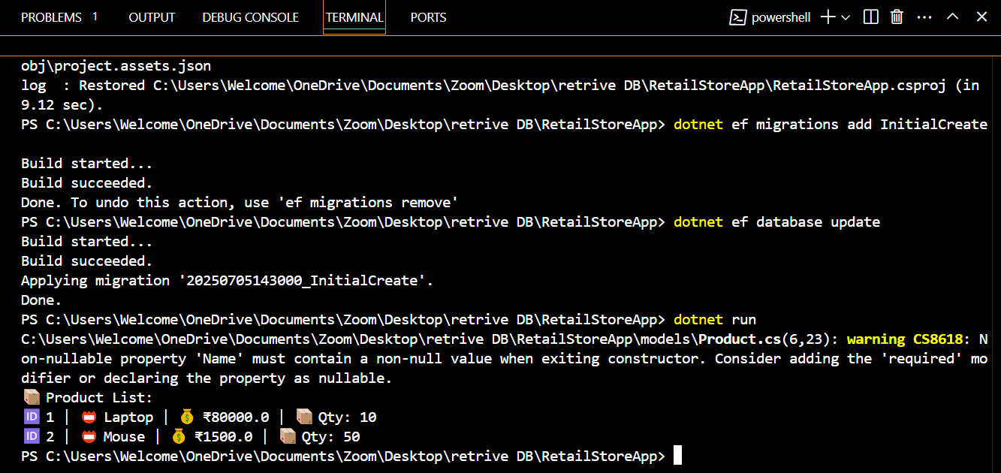

**Name:Ayushman Upadhyay**

**Email:2230164@kiit.ac.in**

**Superset Id: 6358125**